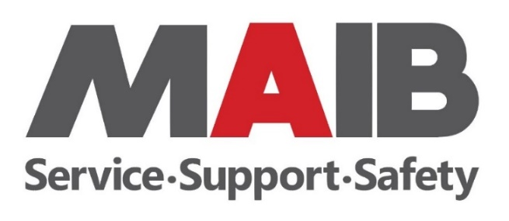

Injury Prevention and Management Foundation (Foundation)

Standard Conditions 2025-26

The following Foundation Standard Conditions apply to all projects approved for funding by the Foundation.

Funding Allocation

- The maximum amount allocated to any one project will be limited to 25% of the annual funding allocated to the Foundation - for the previous financial year (2024-25) the highest funding amount allocated was approximately $243,502 (for a 18-month project);

- The decision of the Foundation Committee regarding the allocation of funding, including the approval or denial of a project, is final and is not subject to further communication;

- If payment is being made by instalments throughout the period of an approved project, it is subject to the timely achievement of agreed deliverables to a quality acceptable to the Foundation;

- Applicants of approved projects are required to sign a Funding Agreement, which will be provided to them by the Foundation; and

- Suitable acknowledgement of the Foundation’s financial support for an approved project must be made in all marketing and communication material including publications, media releases, conference presentations and relevant forums.

Reporting Requirements

- All projects receiving funding from the Foundation are required to submit progress reports and/or final reports (as applicable) detailing the achievement of the agreed deliverables;

- Reports must include details of project expenditure against the allocated budget;

- Reports are to be submitted to the Secretary of the Foundation as advised by the Foundation Committee (on either a quarterly or half yearly basis).

- Failure to submit reports in agreed timeframes may affect the Applicant’s eligibility for consideration in future funding rounds; and

- Any variation in the approved deliverables, timeframes or quality of the funded project must be negotiated in writing with the Foundation prior to their implementation.

Payment of Funding

- Funding for resource acquisition projects may be paid up front with written approval from the MAIB and on receipt of a signed Funding Agreement from the Applicant (this includes projects which require up-front funds to enable the project to proceed) and a satisfactory tax invoice issued to the MAIB;

- Funding of other projects will be advanced on receipt of satisfactory progress reports as applicable. Applicants must provide a satisfactory tax invoice issued to the MAIB with their report(s) as applicable; and

- Where funding remains unexpended at the end of a project, the residual funding must be returned to the Foundation within 14 days of the completion date of the project.

Project Material and Intellectual Property Rights

- Ownership of the project material and Intellectual Property Rights in the project material will rest jointly with the MAIB and the funding recipient in equal shares as equal joint owners; and

- Products and/or deliverables produced through the allocation of funding by the Foundation cannot be used for financial gain by the funding recipient unless prior approval is sought and received in writing from the MAIB.

Other

- The Foundation Committee reserves the right to terminate funding for an approved project where the Foundation Committee is of the opinion that:

  - The project is not being carried out competently;
  - Satisfactory progress is not being achieved;
  - Reporting on the project is unsatisfactory;
  - Funds are being mismanaged; or
  - Funds are not being expended for the purpose for which they were designated.

- Where funding has been terminated, any unexpended funds already allocated must be returned to the Foundation within 14 days of notification of termination; and

- Payment and reporting on projects may be used by the MAIB in its Annual Report and other public communications where appropriate.

